Transport home learning
How many can you complete?
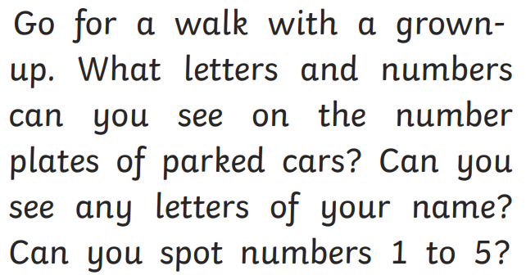 | Can you sing and act out the song the wheels on the bus? What actions can you remember? | Can you draw a picture of how you get to Preschool. Do you walk, ride a bike, go through the park? | Can you create a car wash and wash your toys.
Read a story regarding transport such as Thomas the Tank Engine, The Train Ride, Dig, Dig, Digging, Whatever Next? | Play a traffic lights game where if you say red must stop. Say Amber must walk and if say green then run. Change the actions to amber – jump, green – hop. | 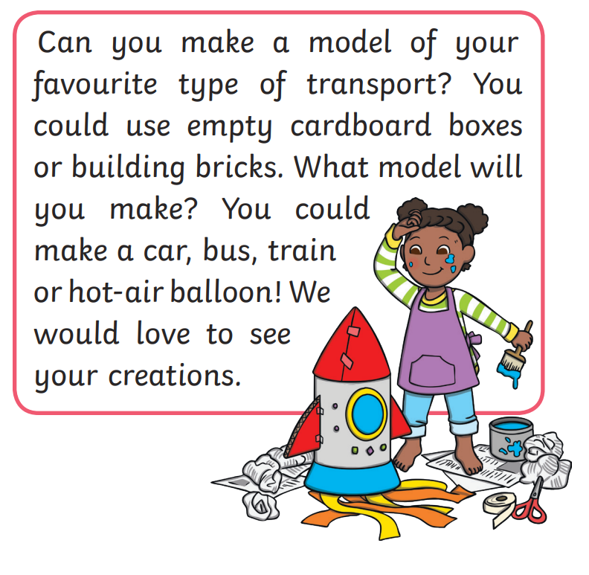 | Watch Maddie Do you know? They have lots of episodes showing how different vehicles work.

