Snail Activities

Snail Trails

You will need
An old container
Black/dark coloured paper or piece of plastic

This is a good activity after it has rained. Go on a snail hunt and gently place the snails in the container. They will probably hide in their shells, this is a good time to observe the shells, colours, patterns and spirals.
Wait quietly and patiently, the snails will reappear from their shells, as they move along the paper you can see their shiny, slimy trails.
Return the snails to where they were found after the activity.

Craft Snails

Glue a spiral shape of string or wool onto a piece of card, when dry use as a print with paint to make a shell for a snail.

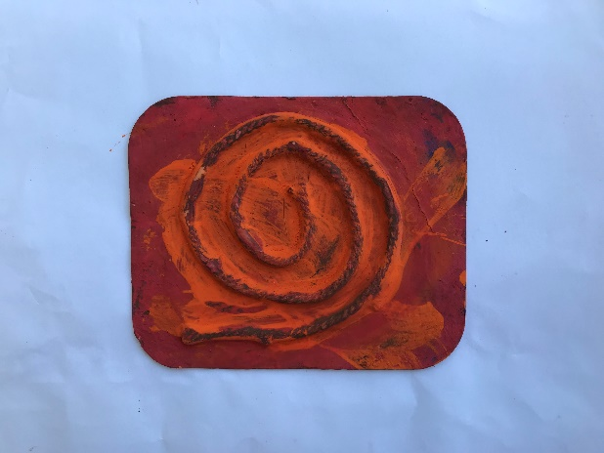

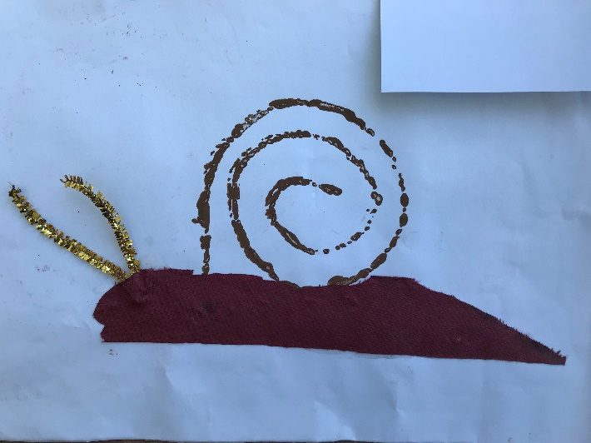
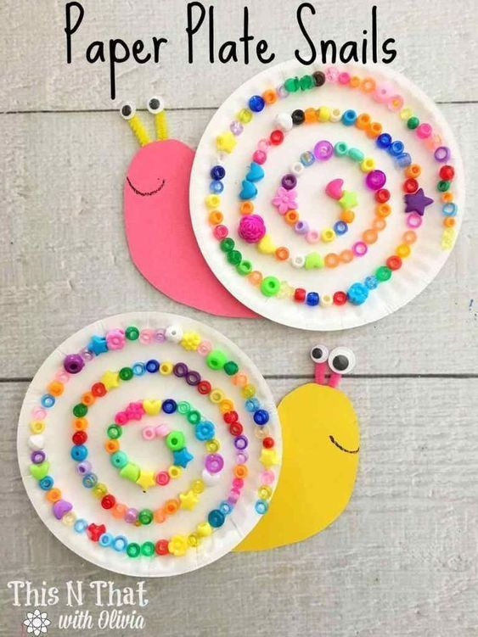
What can you find to make a spiral on a paper plate snail?

