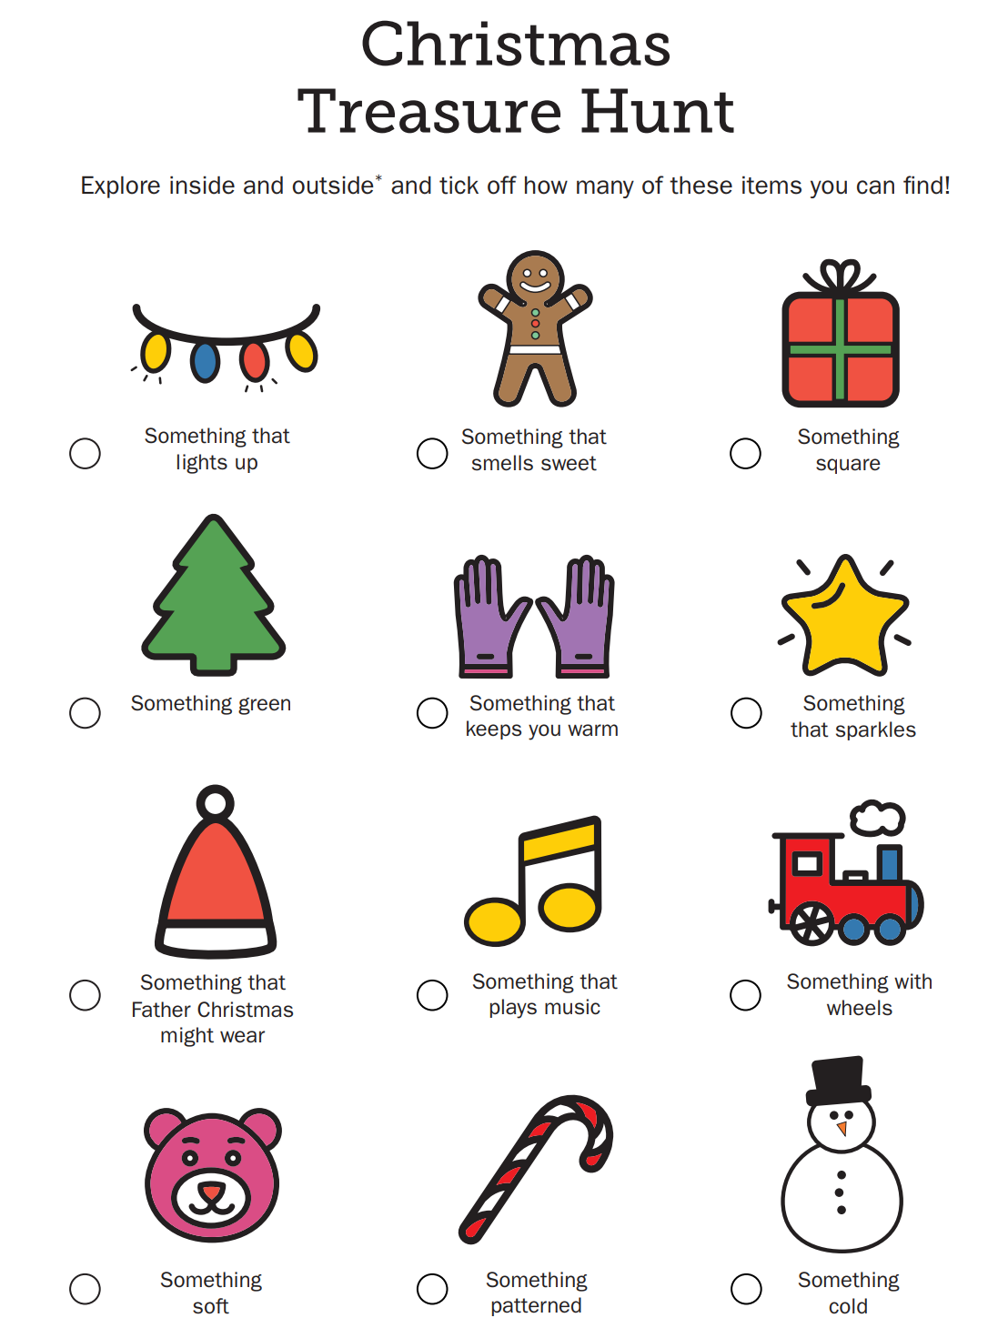

Help Rudolph find his sleigh bells
Hide a set of hand-held jingle bells in a room. Explain to your child that Rudolph needs to find his jingle bells before Christmas Eve and he thinks he left them in this room. Then look for them. When the bells are found sing Jingle bells.

Colour in the tree and look for the shapes in your homes.
