Funny Face Planter

Recycle an empty drinks bottle and plant up with seeds.
At preschool we grow grass seed and practice our scissor skills when the grass gets long to give it a haircut.
Maybe cress or herb seeds could be grown for an edible treat, see sandwich making below.

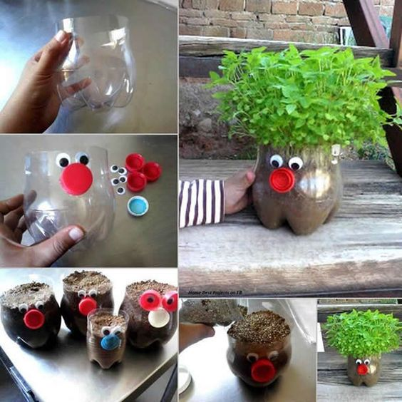

Making sandwiches

Making sandwiches involves using everyday maths words about shapes and numbers.

- How many slices of bread do you need for a sandwich?
- Can you spread the butter and filling to all 4 corners?
- Put the other slice on top and press down .
- Can we cut it in half? How many pieces will we have? What shape are they? Can we cut it in half another way? Can we make triangles or rectangles?
- Can we cut it into 4 quarters? What shape will they be? Squares or triangles?

