Dear Zoo Story home learning ideas

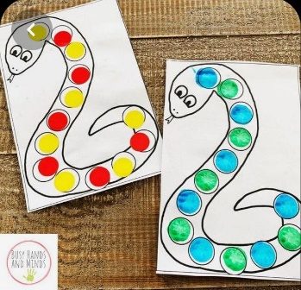

This simple activity will teach children how to repeat patterns, support counting and learning colours.

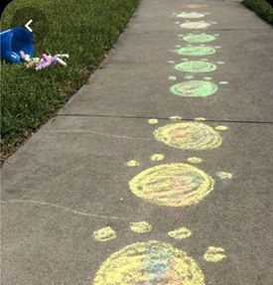
Chalk out some paw prints in the garden and practice jumping and counting as you move from pa to paw.
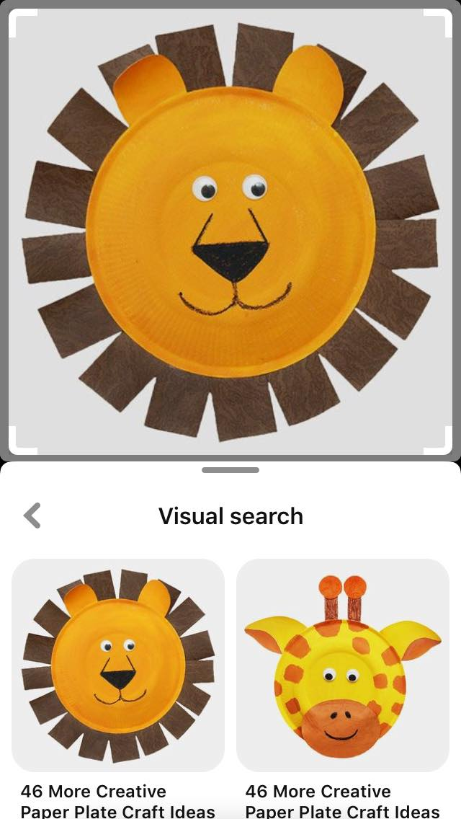
Do you have any paper plates hiding in the cupboard, see if you can recreate some of the characters from the story.

