Animals home learning See if you can complete a line
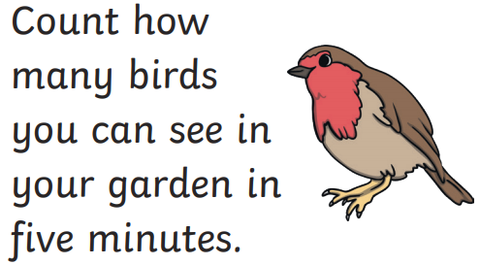 | Read a book about animals what was your favourite part? | Design an animal mask of your favourite jungle animal. | Go for a walk and draw some of the animals you could hear.
Draw a picture of your pet or pets. If you don’t have one draw the pet you would like. | Can you think of animals that start with the letter s, c, d, f | Watch Ferne and Rory’s vet tales on CBeebies. Talk about what happens | 