Here is a list of ideas of things to do with your child if they are off. The activities are the types of things that your child would be doing if they were at Preschool.

- Enjoy stories together.
When we read stories we look at and discuss the different characters, the use of different voices for characters. We also talk about alternative endings.

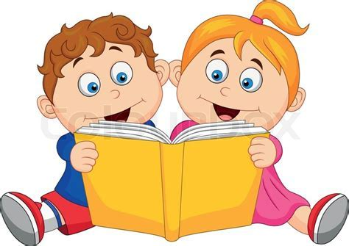

- Letters and Sounds
Our older children are being exposed to far more alliteration throughout daily practice as this is our current focus. We often play simple games like ‘I spy’ or just in conversation notice when words start with the same sound.

- Mark making.
We ensure that there are opportunities everywhere to mark make. Inside or outside. Whilst your child is home it would be great to continue to give opportunity to mark make. For the older children we are particularly looking ensuring the pen hold is correct. Holds pencil near point between first two fingers and thumb and uses it with good control. You can use anything, pens, pencils, crayons, paint brushes and water outside, chalk etc.
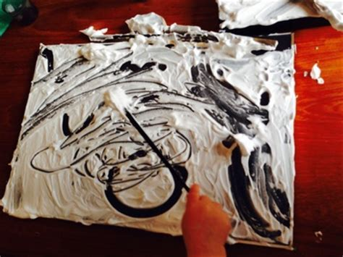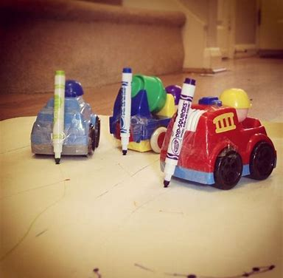
- Cooking
At preschool the children pour their own drinks at snack time. We try to do cooking at various times and encourage as much involvement as possible from the children. It would be good to try and get your children involved in helping to cook, support chopping items, weighing ingredients etc.
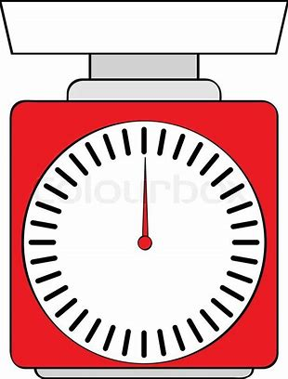

- Playdough
We use playdough a lot to achieve multiple outcomes. From strengthening finger muscles, using with numicon (counting resource), making pretend cakes to be shared out, looking at different prints and marks that we can make in it.
Simple recipe that we use is as follows: 2 cups of flour, 1 cup of salt, 2 cups of hot water and a drizzle of oil.
Sometimes the children make it and we talk about the consistency and what we may need to add more or less of to make it more pliable. We often add food colouring, paint or herbs to make it more interesting.
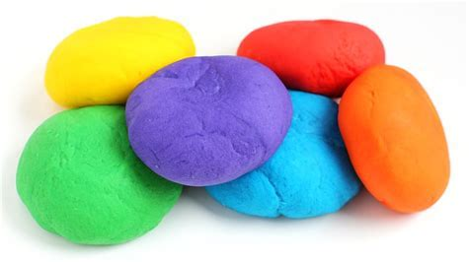

- Make an instrument with recycling you have at home.
We listen to a lot of music from around the world. We incorporate instruments and movement/dancing. We look at the pace of the music, fast slow, quiet loud. We listen to what instruments we can hear in a piece of music. We tend to start our sessions with movement as this sets us up nicely for the day.

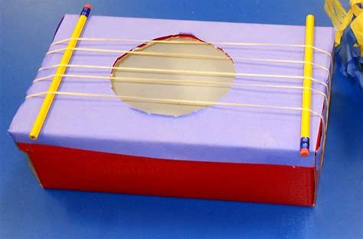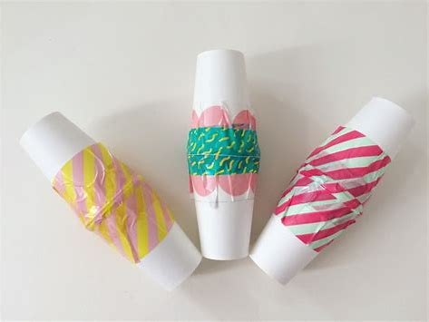

We hope that this gives you some ideas whilst your child is at home.

If you would like anymore resources Twinkl is offering a month of free resources with code UKTWINKLHELPS.
Twinkl is a resource website with activities and worksheets.
To access this use website: www.twinkl.co.uk

